**Week 1 - Assignment**

1. **Describe the usage of Excel String functions LENGTH, MID, RIGHT, LEFT using the below excel sheet.**

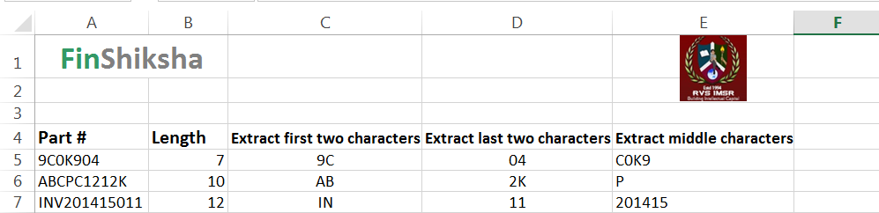

1. **Illustrate the usage of IF condition in below excel sheet.** 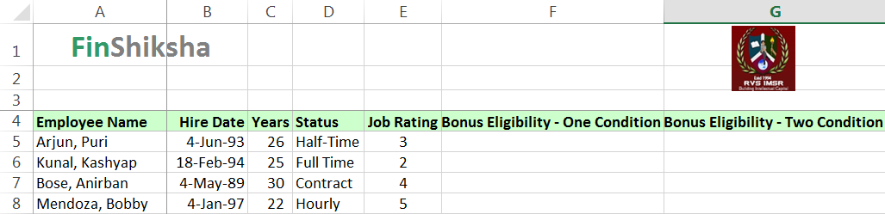
2. **Illustrate the usage of COUNT function in below example.**

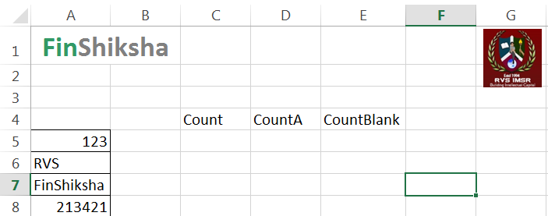

1. **Classify the usage of Logical Operators AND, OR and NOT in the below worksheet.**

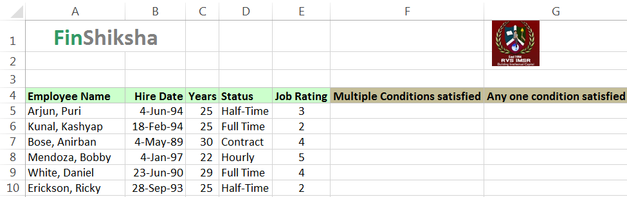

1. **Differentiate the usage of Maths and Logical functions such as COUNTIF and SUMIF in the below excel sheets.**

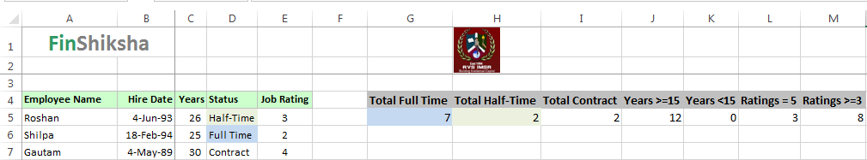

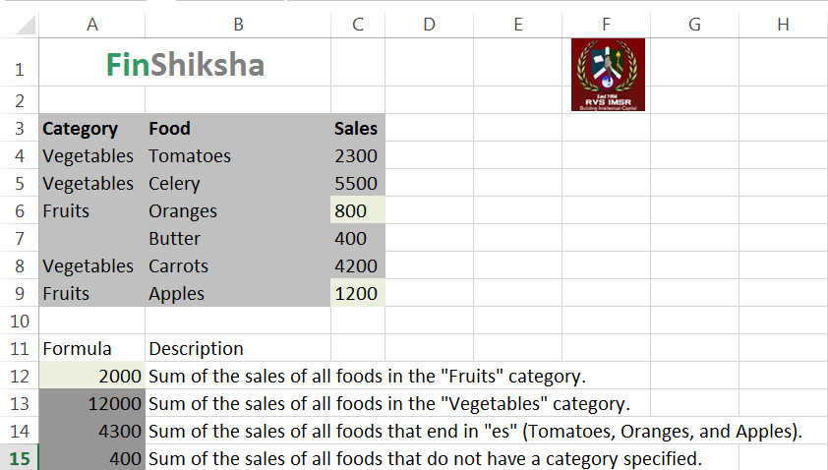

1. **Describe the data formatting techniques for the below excel sheet.**



  